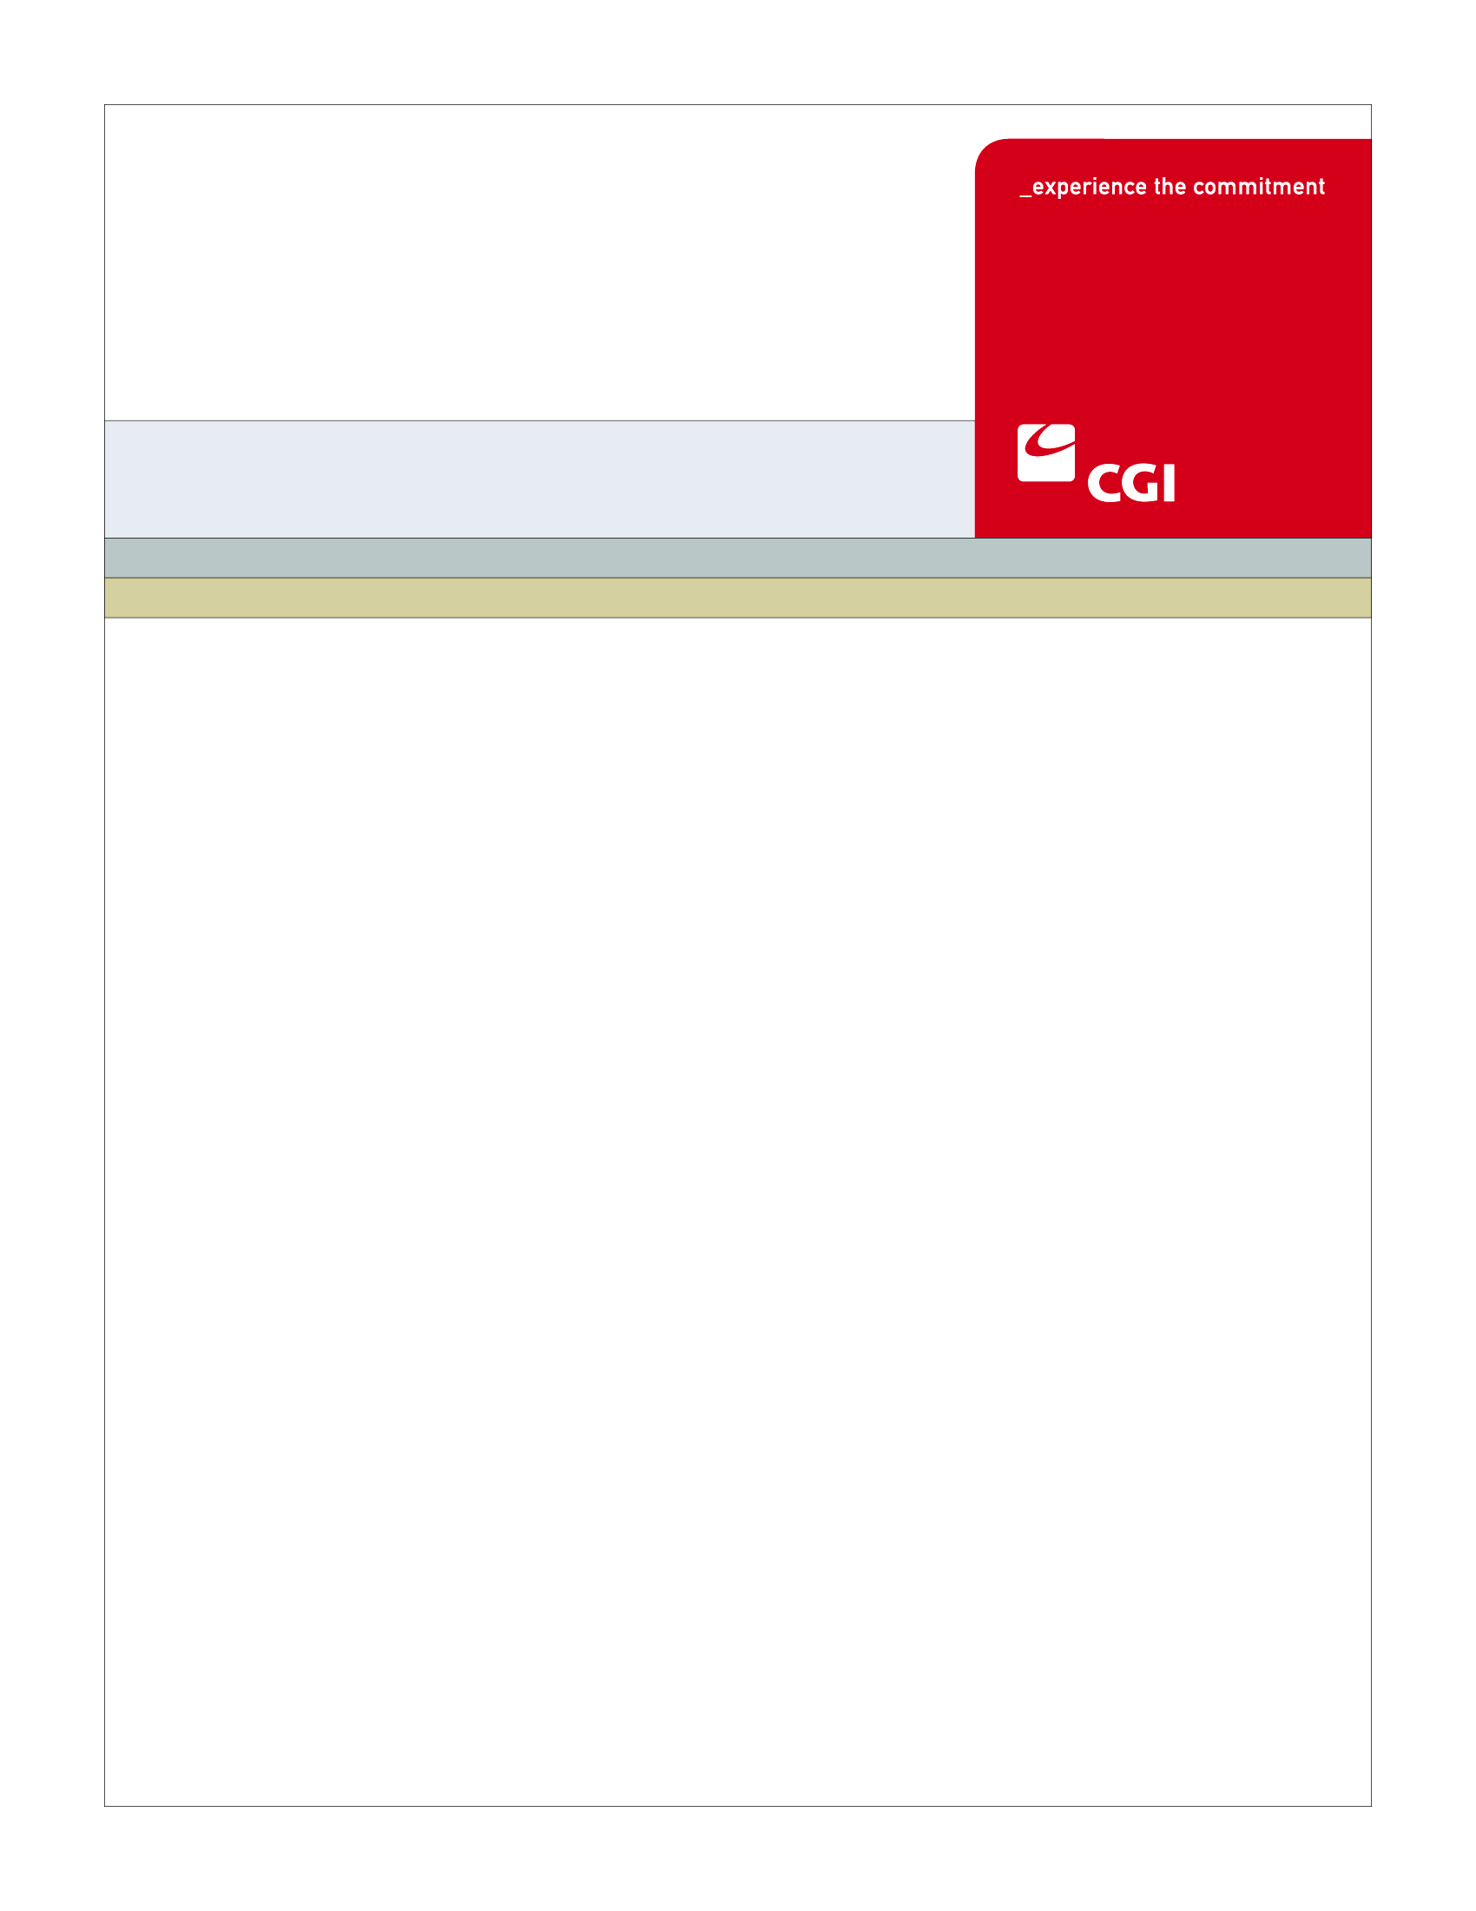

USE

**Colorado Health Benefit Exchange (COHBE)**

**AM-004 Create Navigator Entity/Navigator Account Use Case**

**Version 1.0**

**October 25, 2012**

REVISION HISTORY

|  |  |  |  |
| --- | --- | --- | --- |
| Version | Date | Modified By | Description |
| 0.1 | 10/1/2012 | Rob Merry | Initial draft for JAD Discovery Session |
| 0.2 | 10/10/2012 | Diane Dunn | Elaboration draft, incorporating the Discovery information gained |
| 0.3 | 10/15/2012 | Rob, Diane | Ready for Verification |
| 0.4 | 10/22/2012 | Rob Merry, Diane Dunn | Revised after Verification session of 10/17/12. Changes to having two accounts set up: Navigator Entity and Navigator (worker). |
| 0.5 | 10/24/2012 | Diane Dunn, Rob Merry | Incorporating feedback from COHBE, ready for verification session using new BPM |
| 0.6 | 10/25/2012 | Diane Dunn | Incorporating feedback from Verification Session |
| 1.0 | 10/25/2012 | Diane Dunn | Final version |
|  |  |  |  |
|  |  |  |  |

TABLE OF CONTENTS

1 Use Case: Create Navigator Entity/Navigator Account 5

1.1 Goal 5

1.2 Brief Description 5

1.3 Requirements Traceability 5

1.4 Primary Actor 5

1.4.1 COHBE 5

1.4.2 Navigator Entity 6

1.5 Secondary Actor 6

1.5.1 Exchange 6

1.6 Pre-Conditions 6

1.7 Successful Post-Conditions 6

1.8 Triggers 6

1.9 Assumptions 6

2 Flow of Events 7

2.1 Basic (Main) Flow – Create Navigator Entity/Navigator Account for New User 7

2.1.1 Create Navigator Entity Account 7

2.1.2 Send Notifications 8

2.1.3 Log into Navigator Entity Portal 8

2.1.4 Enter Navigator Account Information 8

2.1.5 Existing Account for Navigator? 8

2.1.6 Create Account 8

2.1.7 Send Confirmation Email 8

2.1.8 Next Steps 8

3 Alternate Flows 9

3.1 Existing Account Found 9

3.1.1 . Duplicate Account Error Message 9

3.1.2 Is Issue Resolvable? 9

4 Exception Flows 9

4.1 Issue is Not Resolvable 9

5 Specifications 9

5.1 Business Rules 9

5.1.1 Required Basic Account Information Fields 9

5.2 Process Rules 10

5.2.1 Existing Account for User? 10

5.3 Workflow 10

5.4 UI Screen Details 11

5.4.1 Navigator Entity Account Screen 11

5.4.2 Navigator Account Screen 12

5.5 Communications 13

5.5.1 Imaging Requirements 13

5.5.2 Form Requirements 13

5.5.3 Notices Requirements 13

5.5.4 Other Communication Requirements 13

5.6 Interfaces 14

5.6.1 No Interfaces 14

5.7 Reporting 14

5.7.1 User Experience 14

5.7.2 Business Activity 14

5.7.3 Workflow 14

5.7.4 Community and Public Health 14

5.8 User Security 14

5.8.1 Actors 14

5.8.2 Sensitive Data 14

5.9 Activity Log and Audit Trail 14

5.10 Data Elements 15

5.10.1 Navigator Entities Account Screen 15

5.10.2 Navigators Account Screen 17

6 Future Release Notes 19

Appendix A - Glossary 19

# Use Case: Create Navigator Entity/Navigator Account

## Goal

The goal of this Use Case is two-fold: To successfully create a Navigator Entity Account and to create Navigator Accounts. When created, the Entity or Navigator can log into the Exchange.

This Use Case completes succesfully when the Entity and Navigator Accounts are created and the Entity or Navigator has a User ID and password to log into the Exchange Navigator Entity Portal.

## Brief Description

As COHBE makes grants to a Navigator Entity, they will create the Navigator Entity Account with an Entity ID (unique log in ID) and defaulted password. The Entity is notified of their account creation. An administrator at the Entity agency will log into the Exchange using this account information. The Entity Administrator will then create Navigator Accounts for their workers. The Navigator ID (unique log in ID) will be assigned by the Entity and a default password given, which will need to be reset by the Navigator after their first log-on. The Navigator will be sent an email notice that the account has been created.

## Requirements Traceability

The following requirements are covered within this Use Case:

* GF077: Third parties such as carriers, navigators and brokers each will have an entry point into the Exchange in order to perform all of their required activities.
* AM141: The System should allow a Navigator to set up an account with multiple logins so that multiple people can log in and create proposals, manage their clients, etc. There should be role specific privileges assigned to each log-in. At this time, the requirement does not include segregation of data or creation of reports for each user/sub-account.

## Primary Actor

### COHBE

COHBE staff will create Navigator Entity Accounts based on the awarded grants.

### Navigator Entity

A Navigator Entity will create accounts for Navigators in their agency.

## Secondary Actor

### Exchange

The Exchange will track and store account information for users of the Exchange. The Exchange will also send notices as appropriate.

## Pre-Conditions

* COHBE has issued a grant(s) to a Navigator Entity or Entities.

## Successful Post-Conditions

* An account is created for the Navigator Entity with an Entity ID and a default password.
* A notification is sent to the Navigator Entity informing them of the account information.
* An account is created for the Navigator in a status of New with an associated Navigator Account ID and default password.
* A notification is sent to the Navigator informing them of the account information.
* Data elements listed as required in Section 5.10 are populated.

## Triggers

The following events trigger this Use Case:

* COHBE approves a grant and notifies the Navigator Entity of the Grant Award.

## Assumptions

* Navigators will need a new account when switching to a new Navigator Entity.
* Navigator Entities will be given a default password. On first log in, they will be prompted to enter new password and answer security questions.

# Flow of Events

The Business Process Activity diagram below shows the COHBE processes for the Create Navigator Entity/Navigator Account Use Case. The steps numbered on the diagram below have detailed explanations in the sections that follow.



## Basic (Main) Flow – Create Navigator Entity/Navigator Account for New User

### Create Navigator Entity Account

COHBE will create the Entity Account and Entity User ID associated to the Navigator Entity. The password will be defaulted.

### Send Notifications

A notification will be sent to the Navigator Entity User informing them they can begin to create Navigator Accounts. The COHBE Navigator Coordinator will also get a notification after the Navigator Entity Account has been created.

### Log into Navigator Entity Portal

After receiving a notification, the Navigator Entity User will log into the Navigator Entity Portal to begin creating Navigators associated to the Navigator Entity. At the time of first log in, the Entity user will reset the password and add Security Questions (see the AM-013 Manage Broker/Navigator Entity/Navigator Information Use Case).

### Enter Navigator Account Information

The Navigator Entity User will access the Navigator Entity Portal to begin creating the Navigator Accounts.

### Existing Account for Navigator?

After entering the required information, the system will check for an existing Navigator Account associated to the Entity (Process Rule, 5.2.1). If no existing account is found, proceed to Step 2.1.6, Create Account. If an existing account is found, proceed to Step 3.1.1, Duplicate Account Error Message.

### Create Account

If no existing account is found, the Navigator Account is created and saved to the database.

### Send Confirmation Email

After the account is created, a notice is sent to the Navigator confirming the account was created. The process then goes to Next Steps.

### Next Steps

The Entity User can proceed to:

* Create another Navigator Account for the next name on the list
* Manage Broker/Navigator Entity/Navigator Account Use Case

After receiving the welcome email, the Navigator Entity user should:

* Enter the Navigator Entity Portal to log on to their account, setting up a password and associated security questions.

After receiving the welcome email, the Navigator user can:

* Enter the Navigator Entity Portal to log on to their account, setting up a password and associated security questions.
* They can then proceed to the Learning Management System (LMS) to begin the Navigator Certification Use Case.

# Alternate Flows

## Existing Account Found

### . Duplicate Account Error Message

If an existing account is found to exist in the Exchange, an error will be returned to the screen saying the account exists.

### Is Issue Resolvable?

If there was a data entry error, the actor can go to Step 2.1.4 to modify the data and try creating the account again. If the issue is not resolvable, the user will exit the Use Case.

# Exception Flows

## Issue is Not Resolvable

If the issue is not resolvable, the Use Case will end.

# Specifications

## Business Rules

### Required Basic Account Information Fields

The Navigator Entity enters data for Step 2.1.4. All fields must be complete using the expected data type and format to check for an existing account (Process Rules, Section 5.2.1, Data Elements, Section 5.10).

## Process Rules

### Existing Account for User?

Step 2.1.5 will check for an existing account associated with the Navigator based information entered on the Create Navigator screen. A verification will be performed to check:

* Duplicate Navigator ID and Navigator Entity ID (combination of the two)

## Workflow

COHBE will do a manual process for creating Navigator Entity Accounts. The process will not be in the Exchange workflow. The process will be defined by COHBE.

## UI Screen Details

### Navigator Entity Account Screen

There is no current hCentive screen for Navigator Entities.

Create a screen with the following fields:

* COHBE Navigator Entity Account ID
* Navigator Entity Name
* Navigator Entity Display/Listing Name
* Navigator Entity ID (used also as unique log in ID)
* Password
* Navigator Primary Email for Customer Use
* Navigator Administrative Email
* Primary Contact
* Address 1
* Address 2
* City
* State
* County
* Zip
* Languages
  + Allow for up to 10 different language fields (to be determined in detail design, the number could be reduced) to be selected from check boxes.
* Areas of Expertise
  + Allow for 15 different areas of expertise (to be determined in detail design) to be selected from drop down lists.
* Areas of Service
  + Allow for check boxes to be selected
  + Areas are: Statewide, Northwest, Front Range, Denver Metro, Northeast, Southeast, South Central, Southwest
* Free-Form Marketing/Out Reach Message
* Navigator Entity Website URL
* Effective From Date
* Effective Through Date
* Upload Documents field with Upload and Browse Buttons

See Section 5.10.1 Business Rules as to which fields are required and which are optional.

### Navigator Account Screen

The current fields in hCentive are based on the Broker/Agent screen (asterisk indicates a required field):

* Broker/Agent* Radio Button Choice
* Email Address*
* Password*
* Company Name
* Broker/Agent ID*
* First Name*
* Last Name*
* Address*
* Zip Code*
* County*
* State*
* Upload Documents (with a Browse button)
* Register button

Modify the following fields:

* From Broker/Agent ID to Navigator ID
* From First Name to Navigator First Name
* From Last Name to Navigator Last Name
* From Address to Address 1

Add the following fields:

* COHBE Navigator Account ID
* Navigator Middle Name
* Navigator Certification Status
* Address 2
* City
* Phone Number
* Specialty Area fields 1, 2, and 3 for drop down list selection

Remove fields for:

* Broker/Agent* Radio Button Choice
* From Company
* Upload Documents
* Security Questions/Answers (which will be added in the Manage Broker/Navigator Entity/Navigator Information Use Case)

See Section 5.10.2 Business Rules as to which fields are required and which are optional.

## Communications

### Imaging Requirements

There are no imaging requirements for the Create Navigator Account Use Case.

### Form Requirements

* The Exchange will provide a structured spreadsheet to allow Navigator Entities to enter a list of Navigators that can be uploaded to create accounts.

### Notices Requirements

* All Navigator Entity Accounts will receive an email notification advising that the Navigator Entity Account was created. This will include the Navigator Entity ID (used as the unique log in ID) and information that will allow the user to deduce their defaulted password.
* When Navigator Entity Accounts are created, an email notification will be sent to the COHBE Navigator Coordinator.
* All Navigator Accounts will receive an email notification advising the Navigator that an account was created. This will include the Navigator ID (used as the unique log in ID) and information that will allow the user to deduce their defaulted password.

### Other Communication Requirements

There are no other communication requirements for the Create Navigator Entity/Navigator Account Use Case.

## Interfaces

### No Interfaces

There are no interfaces for the Create Navigator Entity/Navigator Account Use Case.

## Reporting

### User Experience

* Page abandonment rates

### Business Activity

* Number of accounts created (total)
* Number of accounts created for Navigator Entities
* Number of “dangling” accounts
* Number of Navigators within a Navigator Entity (viewable by Entity)

### Workflow

* Average queue depth

### Community and Public Health

* None at this time

## User Security

### Actors

A Navigator Entity user can access the Entity account and can create Navigator accounts (one by one or through upload).

### Sensitive Data

The data entered into the Navigator Entity or Navigator Account is not sensitive.

## Activity Log and Audit Trail

* No updates at this time.

## Data Elements

This section lists data elements used to create both the Navigator Entity and Navigator as part of this Use Case.

### Navigator Entities Account Screen

| Process Step Reference  **\*Required Field** | Field Name  **\*Required Field** | Required Field? | Action Taken | Actor Performing Action | Format, if known |
| --- | --- | --- | --- | --- | --- |
| 2.1.1 | COHBE Navigator Entity Account ID | * Required | * Create | * System | * Auto-Generated after successful submission |
| 2.1.1 | Navigator Entity Name | * Required | * Create | * COHBE | * Alphanumeric, allow embedded spaces, special characters |
| 2.1.1 | Navigator Entity Display/Listing Name | * Required | * Create | * COHBE | * Alphanumeric, allow embedded spaces, special characters |
| 2.1.1 | Navigator Entity ID | * Required | * Create | * COHBE | * Serves as Unique Log In ID * Assigned by COHBE using SOP * May be Grant Number given by COHBE |
| 2.1.1 | Password | * Required | * Create default | * System | * Assigned by System |
| 2.1.1 | Navigator Primary Email for Customers | * Required | * Create | * COHBE | * name@domain.extension |
| 2.1.1 | Navigator Administrative Email | * Required | * Create | * COHBE | * name@domain.extension |
| 2.1.1 | Primary Contact Name | * Required | * Create | * COHBE | * Alphanumeric, allow embedded spaces and special characters (‘) |
| 2.1.1 | Street Address 1 | * Required | * Create | * COHBE | * Alphanumeric, allow embedded spaces, special characters |
| 2.1.1 | Street Address 2 | * Optional | * Create | * COHBE | * Alphanumeric, allow embedded spaces, special characters |
| 2.1.1 | City | * Required | * Create | * COHBE | * Alphanumeric, allow embedded spaces |
| 2.1.1 | State | * Required | * Create | * COHBE | * Valid State code |
| 2.1.1 | Zip Code | * Required | * Create | * COHBE | * Numbers only |
| 2.1.1 | County | * Required | * Create/May be modified | * COHBE | * Generate from zip code * Allow to be changed, persist the changed value |
| 2.1.1 | Language 10 Language Checkboxes (final number and which languages TBD) | * At least one field is required | * Checkboxes | * COHBE | * Lanuage values to be supplied by COHBE * At least one language must be checked or pre-check English (TBD in design) |
| 2.1.1 | Areas of Expertise 15 separate fields | * First Field Required * Following Fields are Optional | * Chose from Drop Down Lists | * COHBE | * Drop Down list values to be supplied by COHBE * Field 1 default is Generalist * On fields 2 – 15, default to Not Applicable |
| 2.1.1 | Areas of Service Region Checkboxes | * At least one field is required | * Checkboxes | * COHBE | * Statewide * Northwest * Front Range * Denver Metro * Northeast * Southeast * South Central * Southwest |
| 2.1.1 | Free Form Text Field for Marketing and Outreach | * Optional | * Create | * COHBE | * For Marketing / Outreach Information * Expect to copy and paste from Grant Proposal |
| 2.1.1 | Navigator Entity Website URL | * Required | * Create | * COHBE | * domain.extension |
| 2.1.1 | Effective From Date | * Required | * Create | * COHBE | * Valid date |
| 2.1.1 | Effective Thru Date | * Required | * Create | * COHBE | * Valid date * Default to High Date |
| 2.1.1 | Upload Documents Field and Buttons | * Optional | * None | * COHBE | * Not used on Entity Account Creation, used by Entity in Navigator Account Creation |

### Navigators Account Screen

| Process Step Reference  **\*Required Field** | Field Name  **\*Required Field** | Required Field? | Action Taken | Actor Performing Action | Format, if known |
| --- | --- | --- | --- | --- | --- |
| 2.1.5 | COHBE Account ID | * Required | * Create | * System | * Auto-Generated after successful submission |
| 2.1.5 | Navigator ID | * Required | * Create | * Navigator Entity | * Serves as Unique Log In ID * Assigned by Entity |
| 2.1.5 | Navigator Entity ID | * Required | * Create | * Navigator Entity | * Entity ID as assigned by the Exchange * Used to link Navigators to their Entity |
| 2.1.5 | Navigator Entity Name | * Required | * Create | * Navigator Entity | * Alphanumerica, allow embedded spaces, special characters |
| 2.1.5 | Navigator Certification Status | * Required | * Create | * System | * Set to Active Uncertified |
| 2.1.5 | Navigator First Name | * Required | * Create | * Navigator Entity | * Alphanumeric |
| 2.1.5 | Navigator Middle Name | * Optional | * Create | * Navigator Entity | * Alphanumeric |
| 2.1.5 | Navigator Last Name | * Required | * Create | * Navigator Entity | * Alphanumeric |
| 2.1.5 | Street Address 1 | * Required | * Create | * Navigator Entity | * Alphanumeric, allow embeded spaces and special characters |
| 2.1.5 | Street Address 2 | * Optional | * Create | * Navigator Entity | * Alphanumeric, allow embeded spaces and special characters |
| 2.1.5 | City | * Required | * Create | * Navigator Entity | * Alphanumeric, allow embeded spaces |
| 2.1.5 | State | * Required | * Create | * Navigator Entity | * Valid State Code |
| 2.1.5 | Zip Code | * Required | * Create | * Navigator Entity | * Numbers only |
| 2.1.5 | County | * Required | * Create | * Navigator Entity | * Generate from zip code * Allow to be changed, persist the changed value |
| 2.1.5 | Email Address | * Required | * Create | * Navigator Entity | * name@domain.extension |
| 2.1.5 | Phone Number | * Required | * Create | * Navigator Entity | * Numbers only |
| 2.1.5 | Specialty Area  Three separate fields | * First Field Required * Following Fields are Optional | * Chose from Drop Down Lists | * Navigator Entity | * Drop Down list values to be supplied by COHBE * Field 1 default is Generalist * On fields 2 & 3, default to Not Applicable |
| 2.1.5 | Password | * Required | * Create default | * System | * System Default |

# Future Release Notes

* Add functionality for active to and from dates for Navigator: As part of a future release, there may be a request to show when a navigator was activated and deactivated.

# Appendix A - Glossary

| Term | Definition |
| --- | --- |
| Account | An “Account” is the means by which a user can access a computer system |
| Activity Log | An “Activity Log” is a chronological record of every action taken by each user, and by the System on behalf of each user.  The activity log includes actions and events pertaining to transactions, workflow, security (including SIEM), Alerts, Notifications, Approvals and interactions between the user and the System such as submissions of forms, data and documents. |
| Audit Trail | An “Audit Trail” is a subset of records in the Activity Log that are selected and correlated by criteria provided by the auditor or requesting authority. |
| Authorization | “Authorization” is confirmation by a higher or secondary authority of the validity of an action taken by either a lower or primary actor of workflow on the System |
| COHBE | Colorado Health Benefit Exchange, “COHBE” is used interchangeably with “Exchange” throughout the documents. |
| Customer | “Customers” or “Consumers” may be used interchangeably and are terms meant to define individuals or small employers or employees of small employers learning about opportunities to purchase, shopping to purchase, purchasing insurance through the Exchange, or modifying insurance purchased through the Exchange. References to Customers include, as appropriate, dependents of Customers, employees and dependents of employees and others covered by insurance purchased by Customers through the Exchange. |
| DBA | Doing Business As. A legal entity may choose to do business with one or more names. |
| Employer | An “Employer” is a company or small business who participates in the Exchange to offer insurance and/or premium assistance to its Employee(s) or its Employee(s) and their dependents. |
| Exchange | During the implementation phase, the terms “Exchange” or “Exchanges” are meant to include technology, services, business processes, people, and other resources required to implement, operate and/or maintain the requirements or functions needed to support the ability for consumers to shop for and purchase health insurance. Specifically related to interpretation of a requirement, the term “Exchange” implies that the implementation of a requirement is not strictly limited to a technology solution.   * Individually, the term “Exchange” refers to each Exchange or both Exchanges as appropriate in the context. * The Exchange is NOT a state agency but a standalone non-profit entity. It will serve as an aggregator of individual policies sold by private insurers and underwritten using the new federal and state underwriting and rating rules. * The Small Business Health Options Program (SHOP) Exchange will support the specific needs of small employers. * For context, the Exchanges will act much like an “Expedia or Orbitz for Health Insurance” system. They will allow individuals and small firms to obtain information, compare and purchase private health insurance plans. The Exchanges will also be the entities that will evaluate whether or not a particular insurance policy meets the criteria set out by the new federal rules for policies offered to individuals and small employers. |
| Navigator Entities | Navigator Entities are organizations that employ navigators. Navigator entities are provided grants by COHBE to perform navigator functions for the Exchange. |
| Navigators | “Navigators” are persons authorized to assist Customers in their activities to shop for insurance through the Exchanges. |
| Service Representatives | Service Representative (ServRep or SR): A COHBE representative who assists Participants, Customers, and/or Users in using the Exchange and/or the System. NOTE: CSR is used to mean Cost Sharing Reductions and shall not be used to mean ‘customer service representative’. |
| SOP | Standard Operating Procedure. A procedure developed by the COHBE to assure consistency and quality. |
| System | The “System” means all of the software, configurations, data, processes, and equipment used to provide the Exchanges and the System is also referred to as the “solution.” During the implementation phase, “System” is taken to mean the technology component of the Exchange. |
| Users | “Users” are users of the Exchange authorized by COHBE and may include operators, administrators, customers, brokers, navigators, etc., who interact with the System. Users may be internal or external to COHBE. |